- FW: Sussex County EOC video update #4, Sun., Oct. 28, 2012‏

Hurricane Sandy - Sussex County, DE EOC Update #4
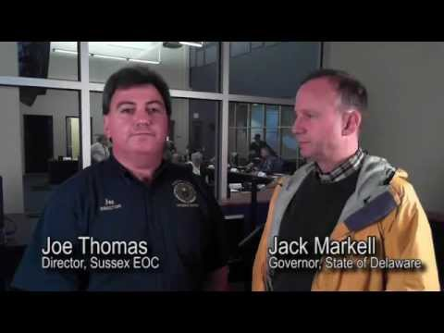 | Play video  Delaware Gov. Jack Markell stops by the Sussex County Emergency Operations Center in Georgetown, Delaware. EOC Director Joe Thomas and the governor update on emergency preparedness actions ahead of…  00:01:53  Added on 10/28/12  2,952 views | 
-----Original Message-----
From: Pam Smith [mailto:administrator@southbethany.org]
Sent: Sunday, October 28, 2012 3:53 PM
Subject: FW: Sussex County EOC video update #4, Sun., Oct. 28, 2012
Importance: High
South Bethany,
Here is the latest video update from the Sussex County EOC:
DE Gov. Jack Markell stops by the Sussex County EOC on Sun, Oct. 28, as
Hurricane Sandy begins to affect state. http://youtu.be/PmzrT2-NYhw
<http://youtu.be/PmzrT2-NYhw>
Chip Guy, Communications Director
Sussex County Government
2 The Circle | PO Box 589
Georgetown, DE 19947
Follow along on Facebook @ www.facebook.com/SussexCountyDE
<http://www.facebook.com/SussexCountyDE> and on Twitter @
www.twitter.com/sussex_pio <http://www.twitter.com/sussex_pio>

